EXP- 10
Git Branching & Merge Conflict

Aim
To resolve merge conflicts using Git.

Procedure
1. Clone the Repository , git clone https://github.com/yourusername/repository-name.gitcd repository-name
2. Create and Switch to New Branch git checkout -b feature-branch
3. Make Changes Edit a file (e.g., README.md or code file)
4. Commit Changes git add . git commit -m "Updated file in feature branch"
5. Push Branch to GitHub git push origin feature-branch
6. Pull Latest Changes from Main git checkout main git pull origin main
7. Switch Back to Feature Branch git checkout feature-branch
8. Merge Main into Feature Branch git merge main
9. Resolve Merge Conflicts (if any) Open conflicting files
10.Mark Conflicts as Resolved git add .
11.Commit Merge Resolution git commit -m "Resolved merge conflict"
12. Push Updated Branch & Create PR git push origin feature-branch Go to GitHub → Create Pull Request
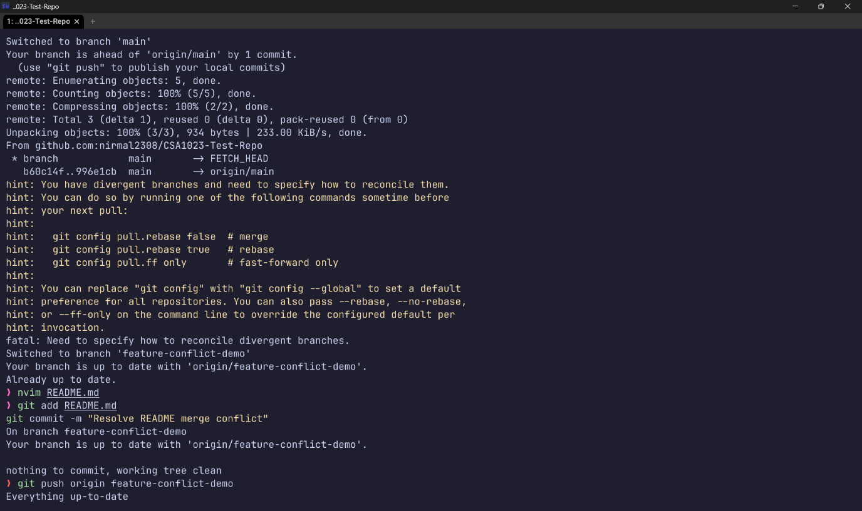

Result: Thus, The Merge conflicts resolved successfully and branch merged.

